Master the Guitar
In 7 Days!



TABLE OF CONTENTS
Day 1 Pgs 4-12
Introduction
Fundamentals of Your Guitar
Tuning
Hand & Finger Basics
Posture

Day 2 – Review of Day 1
(Practice “For What it's Worth”) Pgs 13-21
Open Chords
Major open chords
Minor open chords
Dominant 7th major chords
Major 7th open chords
Diminished chords
Augmented chords
Summary

Day 3 – Review of Day 1 - 2
(Practice “Hurt”) Pgs 22-37
Beginning Theory
Major scales
Minor scales
Harmonic minor scales
Melodic minor scales

Day 4 – Review of Day 1 - 3 Pgs 38-45
Beginning Theory Cont.
Key signature glossary
Notation & other music symbols

Day 5 – Review of Day 1 - 4 Pgs 46-47
Tablature

Day 6 – Review of Day 1 - 5
(Practice “Hey There Delilah”) Pgs 48-64
CAGED system for barre chords
E & A Forms
Power chords
Strumming Patterns

Day 7 – Review all Days
(Practice “Seven Nation Army”) Pgs 65-71
Time to Play
Conclusion

DAY 1

INTRODUCTION

It looks like you want to learn the guitar! Congratulations! You will find this endeavor rewarding and at times, very trying.

I have been a musician for nearly 30 years and am here to inject my musical wisdom into you. There won't be a magic button you can press that will make you good. Practice will be the only way to get where you want to go and play the way you want to play, a lot of practice.

I'm going to walk you through the very basics of your guitar, tuning, posture, how to hold your pick, exercises, notation, tablature, scales, beginning theory, chords, strumming, and some really simple songs you can rock to!

Don't limit yourself to one genre (style) of music. You should really diversify. You will learn so much more by listening to rock, jazz, blues, bluegrass, classical, and Spanish styles of guitar. Be sure that as you learn that you spend time with people that are musicians. Learn from their experience and expertise. Everyone possesses a different interpretation of music and songwriting, so take it as a free lesson.

The last thing I want to say before we get started is have fun. Playing the guitar is an enriching experience with many rewards along the way!

FUNDAMENTALS OF YOUR GUITAR

One of the first things you are going to want to do is get familiar with your guitar, guitar part names, and accessory names. Here is a diagram:
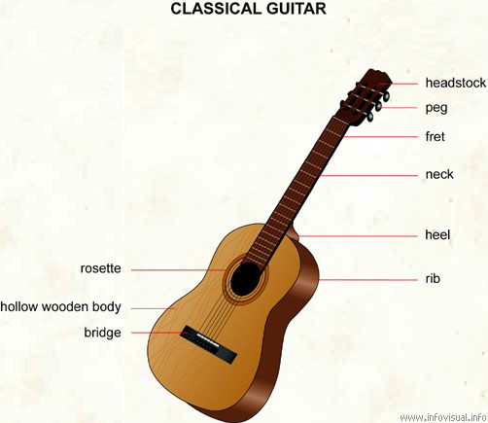

All parts of the guitar are equally important, but some of the areas of particular interest are (from the bottom up) the bridge, strings, neck, fret, and tuning pegs.

Let's begin with the bridge. This is where your stings will be changed. There are round pegs at the end of every string. These will need to be pulled out and new stings inserted. You will need to learn the string names. Beginning from the top (biggest) string to the bottom string (smallest): EADGBE. The top and bottom strings are the same note, just different octaves.

On the neck of your guitar you should notice two things. One, there are going to be a series of metal lines that extend from one end of the neck to the other. These are called frets. Two, if you look down the side of the neck of your guitar you will see dots. The dots are located at frets 3, 5, 7, 9, 12, 15, and 17. Fret 12 has a double dot for which I will explain further once we get to that portion of these lessons.

Let's talk for a minute about the tuning pegs at the top of the guitar on the headstock. This is where the stings end. Before you ever change strings, pay particular attention to which peg each string ends up.

Here is a helpful hint for remembering how the strings are placed into the tuning pegs. If you are holding your guitar in posture (which will be discussed a little later) there will be three pegs pointing toward the ceiling (upright) and three pointing toward the ground (downward). If you are looking at the guitar as the diagram indicates, there will be three pegs on the left and three pegs on the right. Let's work with the latter example. Low E (biggest string) goes into bottom left peg, A goes to middle left peg, D goes to top left peg, G does to top right peg, B goes to middle right peg, high E (smallest string) goes to bottom right peg

Here is an important reminder for you once you have reached this point. Be sure that you thread all strings the same way. What I mean by this is be sure that when you turn the peg clockwise, it tightens the string while counter-clockwise loosens the string. One thing you can try, and I suggest, is that you change out one string at a time. Do not just take out all of the strings and go for it. This is where mistakes happen when trying to get your strings in the correct place and through the tuning pegs. Pay attention to what you are doing so that you don't find your guitar in a mess.

TUNING

Tuning your guitar is one of the most important things you can do for yourself while learning to play. I will go over several methods of tuning for you and ways to train your ears while you learn to tune. Once your ear is trained, you won't have to worry about whether or not the batteries work in your digital tuner.

As a beginner with guitar and perhaps music all together, I suggest that you go get yourself a digital tuner. It is fairly self explanatory. I had one of these as well as a pitch pipe. I liked the pipe because I don't have to buy batteries and it helps my ears train instead of relying on the digital tuner, or meter, to show flat or sharp.

Next, I'd like to discuss tuning with your guitar only. You may wish to tune your bottom E string for this. I call this 5th fret tuning. What you do is tune your bottom E (biggest) string with a tuner or pluck both E strings and listen to the “wa, wa's.” If the wa's are fast, you are sharp. If the wa's are slow, you are flat. If you don't have any wa wa's you are in tune. In succession from the top to the bottom, press the low E string in the 5th fret and then pluck your A string. Listen to the wa wa's and adjust your tuning pegs. Next, press A string in the 5th fret and pluck D string. Press D sting in 5th fret and pluck G string. Press G string in 4th fret and B in 5th fret (note: the switch in frets here). Press B string in 5th fret and pluck E string. This particular form of tuning is great for getting your ear ready to hear music.

Last, but definitely not least, is harmonic tuning. I would consider this a bit more advanced, but once you have your ear trained and have a good idea of how to touch the strings, this is an incredibly accurate method for tuning. It goes something like this: From the top to the bottom, lightly touch your E string at the fret line with your fretting hand, do not press the string, and pluck the string at the same time. You must release the touch with your fretting finger so that the note will continue to play. Play 5th fret E string and 7th fret A string, they should be the same pitch. Play 5th fret A and 7th fret D. Play 5th fret D and 7th fret G. Play 7th fret low E and pluck open B. Last, play 5th fret B and 7th fret E.

Here is a special note for you on harmonics. Harmonics are the result of the vibrations of the string itself.

An important reminder: Be sure that you tune often. Don't just tune at the beginning of a session. Tune several times per session. This will help you hear intonality (when notes aren't in tune) and get your ears trained.

HAND AND FINGER BASICS

Let's talk for a moment on hand and finger basics. You will obviously have one fretting hand, which is the hand responsible for creating chords or single notes, and you will have your picking or strumming hand. Both hands are equally important. I believe that anyone can create a chord with their fretting hand, but the real magic happens with your picking hand as there are so many ways to make sounds come out of the strings.

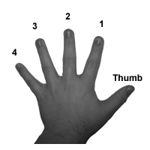

Here is a diagram of your fretting hand and how to refer to your fingers. This will be a great visual aid for correct chord placement. It will be tempting to cheat with finger placement on some of the chords, but there are specific reasons for using specific fingers for constructing the chords.

There is a correct way and an incorrect way to hold a pick with your strumming hand. You'll want to lightly rest the pick between your thumb and forefinger. Your forefinger needs to be arced so that it forms a semi-circle. The pick will rest between the first and second knuckles on the forefinger. Each finger consists of three knuckles, one right above the fingernail, one half way up the finger and the last where the finger meets with the hand. The first and second are referring to the ones right above the fingernail and half way up the finger. From here you will place your thumb on the pick creating a loose yet stable pressure.

As you become more advanced in your guitar playing, you will learn that there are several ways to hold a pick and all of which will be held between the thumb and forefinger. Do not let yourself fall into the trap of holding the pick with the tips of your thumb, forefinger and middle finger. This is incorrect and is a very bad habit to break. It will not allow for your remaining fingers to have any dexterity.

Before I move on to posture, let's talk about dexterity. What is dexterity? It means skill and grace in physical movement, especially in the use of hand. Finger dexterity is of utmost importance when playing any musical instrument and particularly the guitar. Moving your hands and fingers through chords and different scales requires a lot of practice in dexterity.

If you go to a music store, you will find tools to help exercise and strengthen your hands and fingers while building dexterity. Another highly recommended exercise is to purchase a tennis or racquet ball and squeeze them for several minutes to build hand strength. Here are some excellent finger dexterity practices that don't require you to purchase anything:

- Place your hand on a flat surface and lift one finger at a time. Go for accuracy first and gradually build speed. Next, try lifting every other finger and again go for accuracy then speed.

- Spread your fingers out and touch the center of your palm with each finger while keeping remaining fingers as straight as possible. This will help with coordination. Go for accuracy and then speed.

- Crumple a piece of paper with one hand, and then flatten it back out. Repeat this process several times.

- Place your fingertips on a flat surface and practice tapping them in order (refer to hand diagram and finger numbers) 1, 2, 3, 4, 4, 3, 2, 1. Go for accuracy and then speed.

POSTURE

Posture is also very important. Correct posture will help your overall performance. You need to sit up straight and make sure you have a flat back. You may find a tendency to want lean over the front of your guitar so that you can see what you're doing with your fingerings. Instead of looking over your guitar, use your fret dots to know where your fingers are. Ultimately you want to play without looking at your instrument and fingers.

A lot of novice guitar players will sit anywhere; place the guitar on their right thigh and play. You may wonder why this is a problem. Well, when your posture is completely out of alignment, this will result in sloppy wrist, hand, and finger habits. Also, correct chord formations and scale constructs won't be possible up the entire neck of the guitar.

You’ll want to get yourself a chair that fits your height. When you are getting a chair make sure that when you sit in it, your feet are flat on the ground. You also want to make sure that your lap and knees make a 90 degree angle. Any deviation on this will result in incorrect posture. If your chair is too low, your arm, wrist, and finger movements will be limited. If your chair is too high, the tendency will be to lean over your guitar and the result is incorrect posture. A good measure is to stand next to the chair and it should come up to your knees.

Second, you want to get yourself a foot stool. You will use the foot stool to elevate your left leg. The guitar will rest on your elevated left thigh. I caution at getting a foot stool that is too high. While the foot stool allows for the most secure and correct body posture, it can cause some stress to your lower back.

Third, be sure that you sit at the edge of the chair. Do not slouch. Sit up straight. It's okay to look at the guitar and your hand, but it isn't okay to lean over and look at them. Relax your shoulders and keep them square to your torso. Do not let yourself lean to any side. There are a couple of exceptions to this when you are playing up in the twelfth frets and above. Once you have finished in those frets, resume posture. Now I'm sure you have the right foot phenomenon. What to do with the right foot? I tuck it under the chair and rest on the ball of my foot. Some like to have it almost completely extended to where it's almost on the heel. You decide what works best for you.

Last thing I'd like to go over with you are the principles of movement. Our joints work in three different realms of movement. The gist of this is if you put your hand out in front of you and curve the wrist as far left as you can and wiggle your fingers. You should feel tension and pulling in your forearm and wrist. Do the same for the right side. Now keep the wrist in an unbent position and wiggle your fingers. There should be a marked difference in how this feels in comparison to the other two positions.

You also want to keep your fretting arm next to your torso. You don't want it smashed against your rib cage but you also don't want it out there like a chicken wing.

Correct posture is important because as a guitar player, you want to eliminate any excess tension or straining on your body. Believe it or not, real physical conditions can be the result of bad posture. Take the time to be honest about what you need to work on. Bad habits come easy and perfection takes practice.

DAY 2

OPEN CHORDS

Let's begin with open chords. Open chords are basic chord formations that all guitar players learn how to play first.

MAJOR OPEN CHORDS

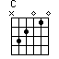
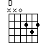
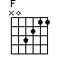
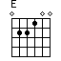
3 2 1 1 3 2 2 3 1 3 2 1 1

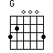
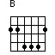
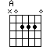
2 1 3 1 2 3 1 1 2 3 4 1

LEGEND: Solid dots represent finger positions. Diamonds represent played notes. X es represent a string or note not played (muted).

Each of these major chords are built from a corresponding major scale. I will go into beginning theory at a later point. Each of these major chords also consists of a triad in notation. The formula for a major triad consists of R-3-5. This means that if your C major scale is: C D E F G A B C, Root = C, 3rd = E, & 5th = G. When you play your C major chord, the only notes strummed are C E G. I suspect this will be kind of confusing but will make sense once you really get to know your fret board and scales.

Here are some of the common ways that these chords and notes will be referred to. CM, DM, EM, FM, GM, AM, BM, C, D, E, F, G, A, B.

MINOR OPEN CHORDS

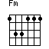
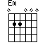
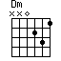
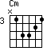
1 3 4 2 1 2 3 1 2 3 1 2 3 1 1 1

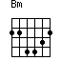
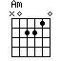
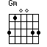
2 1 3 4 2 3 1 1 1 3 4 2 1

All of the symbols represent the same here as they do above. The legend will be applicable for all chords.

Each of the major chords are built from a corresponding minor scale. Each of the minor chords consists of a triad in notation. The formula for a minor triad is as follows: R- (flatted) 3- 5. This means if your C minor scale is: C D Eb F G Ab Bb C, Root = C, 3rd = Eb, 5th = G. Notice that it is exactly the same as a minor triad except for the flatted (b) 3rd. Also, the only notes played will be the R-3-5.

Here are some of the common ways that these chords and notes will be referred to. Cm, Dm, Em, Fm, Gm, Am, Bm, Cmin, Dmin, Emin, Fmin, Gmin, Amin, Bmin.

DOMINANT 7TH MAJOR OPEN CHORDS

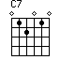
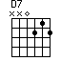
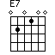
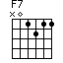
1 2 1 2 1 3 2 1 1 2 1 1

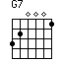
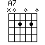
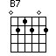
3 2 1 1 3 2 1 3 4

Dominant 7th chord formations are a little different. The principles are still the same as a standard major chord formation but the 7th note is added in. The 7th note played in a dominant 7th chord will be lowered ½ step. If a C major scale is: C D E F G A B C, Root = C, 3rd = E, 5th = G, and 7th = Bb. The formula for this chord formation is R-3-5-7. If we have a four note construct, a triad will still be the basic form in notation with an additional tone, the 7th. This is incredibly useful information as there are several larger chords that are used frequently in music. I will dive into larger chord formations later.

Here are some of the common ways that these chords and notes will be referred to. C7, D7, E7, F7, G7, A7, B7, Cdom7, Ddom7, Edom7, Fdom7, Gdom7, Adom7, Bdom7. Dom = Dominant.

MAJOR 7TH OPEN CHORDS

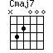
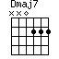
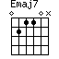
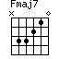
3 2 1 2 3 2 1 1 3 4 2 1

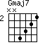
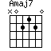
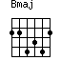
4 3 2 1 1 1 3 2 4 1 2 1 3

* The Bmaj chord is actually Bmaj7. I have checked several references and this is the correct fingering for this chord.

Major 7th chords are again very similar to dominant 7th. The difference here is that the major 7th follows the major scale identically. If a C major scale is: C D E F G A B C, Root = C, 3rd = E, 5th = G, 7th = B. If you notice in a dominant chord B is flat, but not here so don't be confused. Very slight differences make huge changes.

You will usually see these chords written just as they are above.

MINOR 7TH OPEN CHORDS

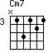
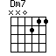
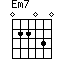
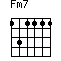
1 3 1 2 1 2 1 1 2 3 4 1 2 1 1 1 1

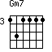
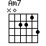
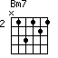
1 2 1 1 1 1 2 3 1 4 1 3 1 2 1

A minor 7th chord is just like the major 7th only with the minor chord formation formula. Let's take a look at what this looks like. A C minor scale is C D Eb F G Ab Bb C, Root = C, 3rd = Eb, 5th = G, and 7th = Bb. The formula for this chord construct is R-3b-5-7. Just like the major 7th chord, a standard triad is built out of the R-3b-5 and the 7th tone is added in.

Here are some of the common ways that these chords and notes will be referred to. Cm7, Dm7, Em7, Fm7, Gm7, Am7, Bm7, Cmin7, Dmin7, Emin7, Fmin7, Gmin7, Amin7, Bmin7.

DIMINISHED CHORDS

From here we will pull what we know about triad building from the major and minor chord forms. The formula for a major chord is R-3-5. The formula for a minor triad is R-3b,5. The formula for a diminished chord is R-3b-5b. In essence all we are doing here is simply flatting the 5th note of the major scale only. A diminished chord looks exactly the same as a minor chord only the 5th note is flatted. R = C, 3rd = Eb, 5th = Gb. Diminished chords will look like this, C dim.

AUGMENTED CHORDS

Augmented chords are again built off of the major chord formula. The major chord formula is R-3-5. An augmented chord formula is R-3-5#. The 5th note is sharp, which is the exact opposite of a flat. A sharped note is raised ½ step instead of lowered. In the case of a C major chord, we already know the notes, R = C, 3rd = E, 5# = G#. You will know you have an augmented chord when you see a + sign. It makes sense if you think about it, a plus sign adds value. Musically, a + sign raises the note a half step. A common augmented chord will look like this, C+5, D+5, etc.

Learning the differences between chords, chords formations and corresponding fingerings will be confusing at best. Memorizing the formula for these will make a world of difference. Think of it as a math formula and that's just what it is. It's fixed. If something changes, it takes on a new name.

SUMMARY ON CHORDS

The reality is that changing chords can be very difficult. My suggestion is that you work with A chords first, followed by the E chords. Practice moving from A to Am to A7, it's simply the removal of a finger or placing a finger in the same string set but different fret. Work through all of your chords this way. Then, practice moving from a C to an Am to an E. Close your eyes and feel where the chords are and learn to trust your hands. Very rarely do you see musicians stare at their guitars while they play. Practice for accuracy then speed. It's okay to make mistakes, you will get better.

“FOR WHAT IT'S WORTH”-
BUFFALO SPRINGFIELD
Strumming Pattern
1 & 2 & 3 & 4 &
D D U U U

This song is a simple song. It consists of 2 open chords, E and A. It's in 4/4 time, which means that each chords will get 4 counts. Practice slowly enough to try and get the chord change in there without a pause in the song. Here are the lyrics and chord placements:
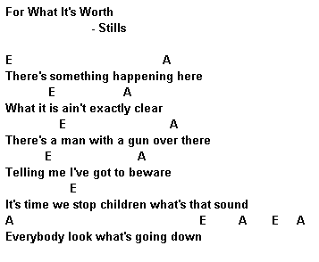
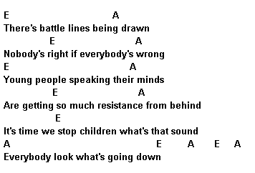

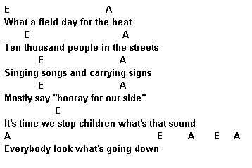
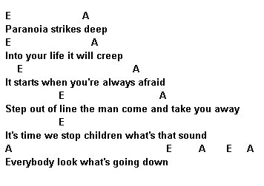

DAY 3

BEGINNING THEORY

Beginning music theory may not sound like a lot of fun or even something you are interested in. It is crucial that you learn the fundamentals of music so that you can start programming your brain to think in terms of music. Music theory will give you a greater understanding of what you are playing and why. This will probably take the longest to learn which is why I gave you some chords to work on first. Most people like to dig in and play and not sit down and study before they begin to play! While you practice the series of chords given, build on in theory.

MAJOR SCALES

Before I begin with how to construct a major scale, know this as a constant, there are only twelve notes in existence. C C#/Db, D, D#/ Eb, E, F, F#/Gb, G, G#/Ab, A, A#/Bb, B, C. This is called a chromatic scale which includes every note known. A chromatic scales consists entirely of half steps. Take special note that there isn't an E# or Fb, B# or Cb.

Example: In ascending order, C to C# is a half step, C# to D is a half step, D to D# is a half step, etc. In descending order, C to B is a half step (note that there isn't a Cb or B#), B to Bb is a half step, Bb to A is a half step, etc.

A scale is comprised of whole (w) and half (h) steps. The term scale comes from the Latin word scala which means ladder. An easy way to remember this is that a scale climbs like a ladder of notes. If we use a C major scale as an example while referencing the chromatic scale, the major scale construct will be easier to understand. A scale is comprised of 8 steps which can be either whole or half steps.

Example: C D E F G A B C. C to D is a whole step, D to E is a whole step, E to F is a half step, F to G is a whole step, G to A is a whole step, A to B is a whole step, B to C is a half step. Notice that the half steps occur where the notes don't exist (E#, Fb, B#, and Cb).

Our major scale formula is this: WWHWWWH. Memorize it!

What are the major scales?

C Major Scale: C D E F G A B C ( 0 sharp, 0 flat)

G Major Scale: G A B C D E F# G ( 1 sharp, f#)

D Major Scale: D E F# G A B C# D ( 2 sharp, f#, g#)

A Major Scale: A B C# D E F# G# A ( 3 sharp, f#, g#, c#)

E Major Scale: E F# G# A B C# D# E ( 4 sharp, f#, g#, c#, d#)

B Major Scale: B C# D# E F# G# A# B ( 5 sharp, f#, g#, c#, d#, a#)

F# Major Scale: F# G# A# B C# D# E# F# ( 6 sharp, f#, g#, c#, d#, a#, e#)

C# Major Scale: C# D# E# F# G# A# B# C#) ( All sharp)

F Major Scale: F G A Bb C D E F ( 1 flab, Bb)

Bb Major Scale: Bb C D Eb F G A Bb ( 2 flat, Bb, Eb)

Eb Major Scale: Eb F G Ab Bb C D Eb ( 3 flat, Bb, Eb, Ab)

Ab Major Scale: Ab Bb C Db Eb F G Ab ( 4 flat, Bb, Eb, Ab, Db)

Db Major Scale: Db Eb F Gb Ab Bb C Db ( 5 flat, Bb, Eb, Ab, Db, Gb)

Gb Major Scale: Gb Ab Bb Cb Db Eb F Gb ( 6 flat, Bb, Eb, Ab, Db, Gb, Cb)

Cb Major Scale: Cb Db Eb Fb Gb Ab Bb Cb ( All flat)
Below is something known as the circle of fifths. This is a wheel of information that will aid you in scale construction, key signatures, and note names. Helpful hints: When you are trying to figure out which note will be sharp, look to the previous note on the wheel beginning with F (F C G A E B). A Gmaj. Scale has 1 # which is F#, etc. When you are trying to figure out which note will be flatted next, look to the next note beginning with B (B E A D G Cb). An F maj. Scale has 1 b which is Bb, etc.

NOTES ON THE FRETBOARD

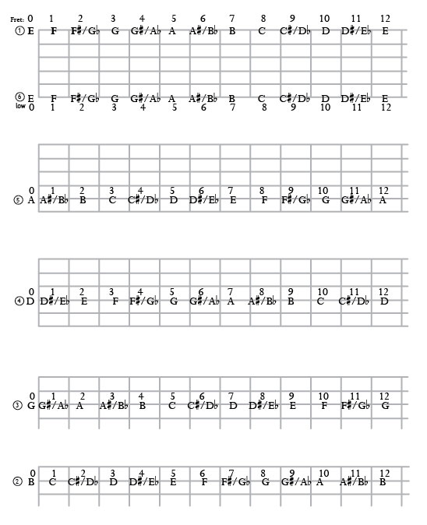
Here are some helpful tips. Each string will contain a chromatic scale which is the 12 notes I have already discussed. Your open string note will be the same as your note at the 12th fret and that is the case for every string. Here is an exercise for you to learn: when you ascend (climb) the fretboard, practice the notes in sharps. When you descend the fretboard, practice the notes in flats.
Do this with every string. Practice first for accuracy, then for speed.

MINOR SCALES

A minor scale is going to have some of the same principles as a major scale. It still consists of 8 steps, some whole steps and some half step. The formula for a minor scale is: WHWWHWW. Memorize it! I must explain real quick, there are three different types of minor scales, natural, harmonic and melodic. The formula above is for a natural minor scale. I will explain the difference between a natural and harmonic minor scale later. It may be easier to understand a natural minor scale by showing the individual steps of the scale. Remember, there are 8 steps to a scale. 1 2 3b 4 5 6b 7b 8. Steps 3,6,7 are lowered ½ step. You may ask yourself, why does it show a whole step for the last step of the formula. If you remember, on a major scale, step 7 to 8 is only a ½ step. If you lower step 7 by a half what is left is a whole step between the two (just like math 2 halves make a whole).

Let's put what we know to work and construct our natural minor scales.

C minor scale: C D Eb F G Ab Bb C

D minor scale: D E F G A Bb C D

E minor scale: E F# G A B C D E

F minor scale: F G Ab Bb C Db Eb F

G minor scale: G A Bb C D Eb F G

A minor scale: A B C D E F G A

B minor scale: B C# D E F# G A B

C# minor scale: C# D# E F# G# A B C#

Eb minor scale: Eb F Gb Ab Bb Cb Db Eb

F# minor scale: F# G# A B C# D E F#

G# minor scale: G# A# B C# D# E F# G#

Bb minor scale: Bb C Db Eb F Gb Ab Bb

HARMONIC MINOR SCALES

A harmonic minor scale builds off a natural minor scale. To play a harmonic minor you raise the 7th step of the scale by a ½ step. The formula for this scale is WHWWHWH.

Example:
Natural Minor Scale: C D Eb F G Ab Bb C

Melodic Minor Scale: C D Eb F G Ab B C

Your harmonic minor scales will look like this:

C harmonic minor scale: C D Eb F G Ab B C
G harmonic minor scale: G A Bb C D Eb F# G
D harmonic minor scale: D E F G A Bb C# D
A harmonic minor scale: A B C D E F G# A
E harmonic minor scale: E F# G A B C D# E
B harmonic minor scale: B C# D E F# G A# B
F# harmonic minor scale: F# G# A B C# D E# F#

C# harmonic minor scale: C# D# E F# G# A B# C#

G# harmonic minor scale: G# A# B C# D# E F##(G) G#

Eb harmonic minor scale: Eb F Gb Ab Bb Cb D Eb

Bb harmonic minor scale: Bb C Db Eb F Gb A Bb

F harmonic minor scale: F G Ab Bb C Db E F

Special Note:

You have probably noticed the double sharp in the G# harmonic scale. A double sharp essentially means you raise the note a whole step instead of a ½ step. As indicated above an F## is the same as a G. The same principle applies to a double flat. You would lower a note a whole step. A Bbb would be the same as an A. Again it's the same as math, if you increase by 2 half steps, you have a whole step. If you lower by 2 half steps, you have a whole step. 2 halves equal a whole.

MELODIC MINOR SCALES

A melodic minor scale builds off of both the natural and harmonic minor scales. This is accomplished by raising the 6th step ½ step.

Example:
C Natural Minor Scale: C D Eb F G Ab Bb C
C Harmonic Minor Scale: C D Eb F G Ab B C
C Melodic Minor Scale: C D Eb F G A B C

Here's the trick with a melodic minor scale! In classical music theory, a melodic minor scale is only used while ascending. When you go to descend, it switches back to a natural minor scale.

Here's what that looks like: C D Eb F G A B C C Bb Ab G F Eb D C.

Got it? Good!!!

But how do I know where flats and sharps go? Let's go over this, it's simple.

Here we are with the circle of fifths again! This will be your be-all end-all for information. Let's review. In a C major scale, the sixth step an A. An A minor scale will have the same key signature (or same number of sharps or flats) as the C major scale. You plug the notes into the corresponding minor formula and bam, you have a new scale. What is a key signature? Key signature will let you know if a note is sharp, flat, and which notes they are. Let's put this in a really good visual aid:

C major: C D E F G A B C ( WWHWWWH)
A natural minor: A B C D E F G A ( WHWWHWW)
A harmonic minor: A B C D E F G# A (raised 7th step)
A melodic minor: A B C D E F# G# A (raised 6th and 7th steps)

ALL OF THESE SCALES USE THE SAME KEY SIGNATURE.

If you follow the wheel around clockwise, each major scale has a corresponding minor note that you will find on the inside of the wheel. Just simply remember it is the 6th note in the major scale. You will use the same sharps or flats as the major scale for you minor scale construction.

“HURT”-
JOHNNY CASH
LYRICS: TRENT REZNOR

This song will cover some of the basic open chords we've already gone over. You'll also see some formations I haven't gone over yet. All fingerings will be included with the song along with notation and tablature. From the music you should be able to figure out the strumming pattern as it will be indicated in notation.
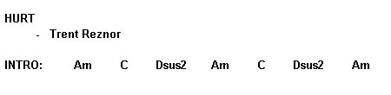
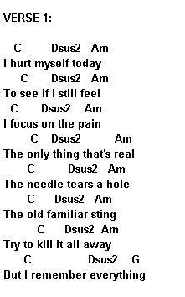
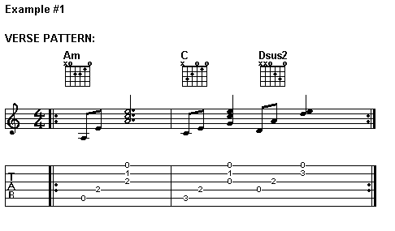
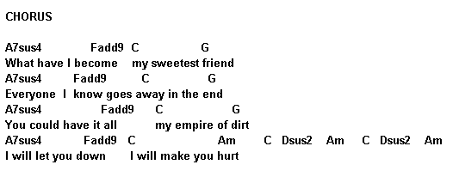
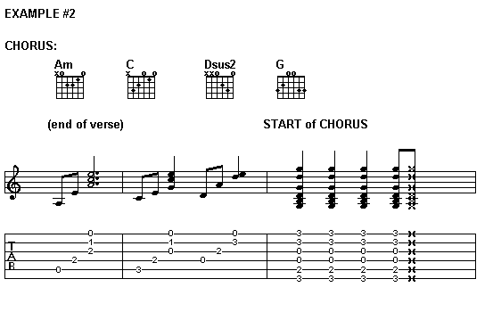
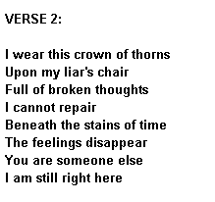
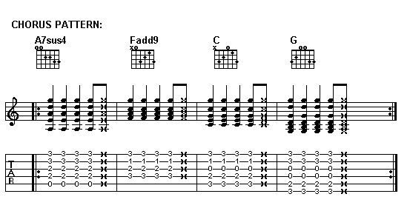
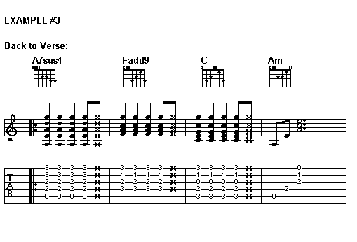
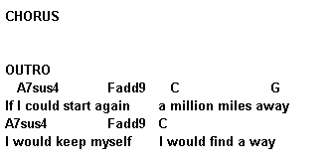
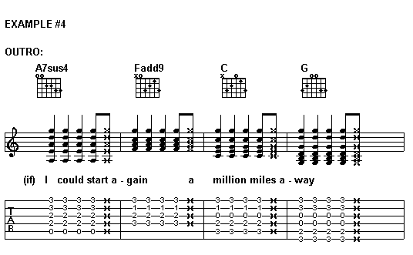
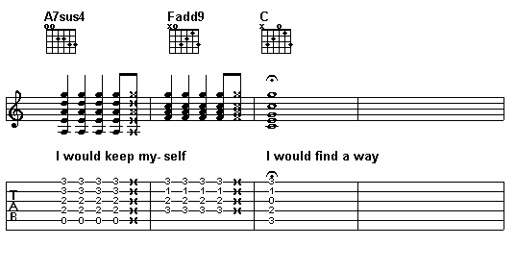

DAY 4

KEY SIGNATURE GLOSSARY
WITH CORRESPONDING MINORS

Key Signature | Added ♯ | Major Key | Minor Key | Key Signature | Added ♭ | Major Key | Minor Key
1 sharp | F♯ | G major | E minor | 1 flat | B♭ | F major | D minor
2 sharps | C♯ | D major | B minor | 2 flats | E♭ | B♭ major | G minor
3 sharps | G♯ | A major | F♯ minor | 3 flats | A♭ | E♭ major | C minor
4 sharps | D♯ | E major | C♯ minor | 4 flats | D♭ | A♭ major | F minor
5 sharps | A♯ | B major | G♯ minor | 5 flats | G♭ | D♭ major | B♭ minor
6 sharps | E♯ | F♯ major | D♯ minor | 6 flats | C♭ | G♭ major | E♭ minor
7 sharps | B♯ | C♯ major | A♯ minor | 7 flats | F♭ | C♭ major | A♭ minor

NOTATION AND OTHER MUSIC SYMBOLS

I'm going to start off with very basic notes and symbols that you will need to know. I hope that you will learn to read in notation, however, if you choose not to, you'll need to understand other symbols to correctly read tablature. Let's begin!

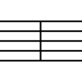
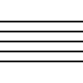
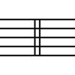
Staff Bar Line Double Bar Line

Staff: This is the set of lines upon which notes are placed. Beginning from the bottom line and continuing to the top, notes read E G B D F (rhyme to help remember, Every Good Boy Does Fine). The notes in between are F A C E.

Bar Line: Bar lines are used to separate measures in a musical piece.

Double Bar Line: A double bar line is used to separate to major sections of music inside a piece. They may be used at a temp change or key change.

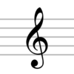
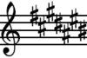
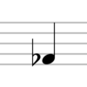
Accolade Treble Clef Flat Key Signature Sharp Key Signature

Accolade: Used to connect two or more lines of music that are played at the same time.

Treble Clef: A treble clef, also known as a G clef, is the most common clef used in music. G clef is derived from the stylized G shape of the clef and the inside spiral circles the G line on the staff.

Key Signatures: Flat key signatures will indicate which note will be flatted. Sharp key signatures will indicate which notes will be sharp.

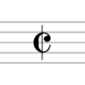
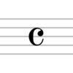
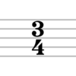
Specific Time Common Time Cut Time

Specific Time: The bottom number (4) refers to quarter notes. The top number (3) indicates how many quarter notes you will find in a measure. In this case there will be 3 quarter notes per measure. Also referred to as Three Four time. This will vary from piece to piece as there are numerous specific times.

Common Time: Common time is used today to represent 4/4 time. Also referred to as Four Four time. If it is used as specific time it would indicate that there are 4 quarter notes per measure.

Cut Time: Cut time is just like it sounds. It represents 2/4 time. Also referred to as Two Four time. The same is true here also where there would be 2 quarter notes per measure.

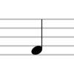
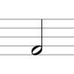
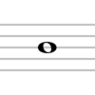
Whole Note Half Note Quarter Note

Whole Note: A whole note gets four beats. In 4/4 time it would count an entire measure.

Half Note: A half note gets two beats. In 4/4 time two half notes would be played.

Quarter Note: A quarter note gets one beat. In 4/4 time four notes would be played.

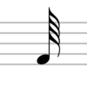
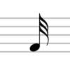
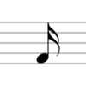
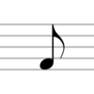
Eighth Note Sixteenth Note Thirty-second Note Sixty-fourth Note

Eighth Note: An eighth note receives a half beat. In 4/4 time you would play eight notes per measure.

Sixteenth Note: A sixteenth note receives a quarter of one beat. In 4/4 time you would play sixteen notes per measure.

Thirty-second Note: A thirty-second note receives a sixteenth of one beat. In 4/4 time you would play thirty-two notes per measure.

Sixty-fourth Note: A sixty-fourth note receives a thirty-second of one beat. In 4/4 time you would play sixty-four notes per measure.

In a typical measure you will find a variety of notes and will very rarely contain all of one note.

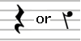
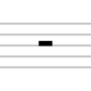
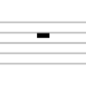
Whole Rest Half Rest Quarter Rest

Whole Rest: A whole rest gets 4 counts. In 4/4 time it would receive 4 counts per measure and in 2/4 time it would receive 2 counts per measure.

Half Rest: A half rest gets 2 counts. In 4/4 time it would receive 2 counts per measure and in 2/4 time it would receive 1 count per measure.

Quarter Rest: A quarter rest gets 1 count. In 4/4 time it would receive 1 count per measure and in 2/4 time it would receive ½ count per measure.

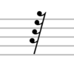
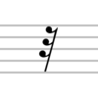
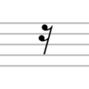
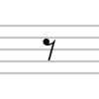
Eighth Rest Sixteenth Rest Thirty-second Rest Sixty-fourth Rest

Eighth Rest: An eighth rest gets ½ of one count. In 4/4 time it would receive ½ count per measure and in 2/4 time it would receive ¼ count per measure

Sixteenth Rest: A sixteenth rest get ¼ of one count. In 4/4 time it would receive ¼ of a count per measure and in 2/4 time it would receive 1/8 of a count per measure.

Thirty-second Rest: A thirty-second rest gets 1/16 of one count. In 4/4 time it would receive 1/16 of a count per measure and in 2/4 time it would receive 1/32 of a count per measure.

Sixty-fourth Rest: A sixty-fourth rest gets 1/32 of one count. In 4/4 time it would receive 1/32 of a count per measure and in 2/4 time it would receive 1/64 of a count per measure.

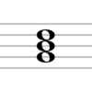
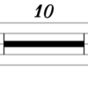
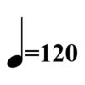
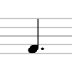
Dotted Note Beats Per Minute Extended Rest Triad

Dotted Note: Placing a dot to the right of any note value lengthens the value by one half its value. A dot can also be placed to the right of a rest causing the same to happen, increased value.

Beats per Minute: This indicates how many quarter notes will occur in one minute. You should really have a metronome so that you understand tempo and you can set the beats per minute. A metronome is a piece of equipment that keeps time. You can buy this at a music store.

Extended Rest: An extended rest will cover more than just a specific amount of time inside a measure. It will be for the indicated number of measures. In this case it is 10 measures of rest.

Triad: This is a picture of what a triad looks like. I have spent quite a bit of time talking about how to build one.

SUMMARY ON THEORY

I don't expect for you to become a guru on theory as you begin to play the guitar. This lesson is here to help you build on your current skills so that your knowledge expands while you practice chords and scales. A comprehensive understanding of what you are playing and why it is the way it is will take you far in your endeavors. My suggestion for you is to work on one scale at a time and say each note while you play it.

There are plenty of free places on the internet that will allow you to print staff paper where you can practice writing your notes so that you see where they are placed while you learn how they sound. Some people learn by written material and some are visual. Do what works best for you. You will come across everything I have written while you learn songs. This is merely a guide to help you understand what you are looking at.

DAY 5

TABLATURE

What is tablature? Tablature, tab for short, is a form of musical notation with an emphasis on fingerings rather than traditional notation. Tablature is commonly used for fretted instruments.

Tablature reading is used most often by novice musicians. The problem with tablature is that it doesn't indicate note length or duration. This is where understanding note values will help as most tablature is written below standard notation.

Tablature is a closer visual representation of your guitar fretboard, thereby making it easier to interpret music. It virtually doesn't require any training to become quite good at reading it.

Tablature takes the guess work out of which fret to play chords or notes. Standard notation has often left this a gray area but in some cases will indicate frets by placing roman numerals below the staff.

Below is a sample of what guitar tablature looks like and how to read it. Some key points to remember are that tablature will be read upside down in comparison to how the strings are on your guitar. If you remember, your strings read from top to bottom EADGBE. Tablature reads from top to bottom EBGDAE.

The chords E, F, and G:

e|---0---1---3---
B|---0---1---0---
G|---1---2---0---
D|---2---3---0---
A|---2---3---2---
E|---0---1---3---
E F G

Each of the single columns represents a chord fingering. The G string is pressed in the 1st fret and the D and A strings are pressed in the 2nd fret. One problem with tablature is that it doesn't indicate correct finger positions for the chords. Correct finger positions are essential as we move into barre chords, commonly known as power chords used in most music.

If you begin reading tablature instead of notation, you'll find yourself able to get through a piece more quickly, but limited in many other ways as tablature lacks musical structure that makes a song beautiful and dynamic.

DAY 6

CAGED SYSTEM FOR BARRE CHORDS

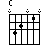
C position A position G position E position D position

This system is very simple. I will teach it to you as simply as possible with visual examples of chords to guide you through the process. The five positions above are considered movable. Let's start with an easier example of how these positions move. If you start with an open E chord, you can slide that position up one fret and barre with your first finger. You will also have to adjust your finger positions accordingly. Once you have barred the first fret and moved the E position up one fret, you have a new chord, F major. You can do this all the way up the fret board chromatically. Once you have hit the 12th fret, you are at an octave higher E chord.

If your chord begins in the 2nd fret (such as A, D, G) there will be a one fret space between the barre and the chord formation. Each of the formations can be moved up the fretboard chromatically and each of the chords are an octave higher at the 12th fret. Chords B major and F major are extensions of the E and A chord forms.

Here's a helpful hint: Every open chord formation is considered movable. There are a lot of websites designed for helping newbies through the CAGED system. Below is an example.

A FORM

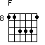
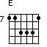
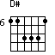
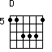
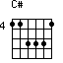
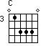
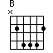

E FORM
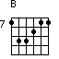
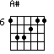
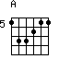
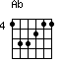
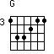
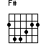
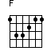
In the A form you will notice that I used an Ab instead of a G#, they are the same chord/note. Anyhow, now you can see how the system is used and can be done for all open chord forms.

POWER CHORDS

Power chords are very similar to barre chords. As you remember, barre chords (and other chord formations) are comprised of R-3-5. Power chords are simply R-5. Power chords are not considered true chords since they lack the 3rd and are called dyads. It makes sense, dy meaning 2. Below are some examples of power chords.

A lot of modern rock songs use power chords so you will see them come up in the songs later on. They are much simpler and they sound great. Don't forget to practice your other chord formations though!

STRUMMING PATTERNS

Strumming your guitar can be an interesting challenge as you get started. It may be difficult to get your chords to sound good. All of this will get better with time and practice. A lot of newbie guitar players want to strum the strings to hard. This results in an annoying “twangy” effect. You'll want to avoid this at all costs!

Here are some helpful tips for getting a good sound:
- Be sure to hold your pick correctly.
- Be sure you don't hold the pick too tightly.
- In a downward motion, lightly glide the pick over your strings.
- Don't try and strum to fast. Go for accuracy then speed!
- Practice strumming whole notes, half notes, quarter notes, eighth notes, and sixteenth notes.
- Practice note values using a downward strum first.
- Practice note values using a down/up pattern (go for accuracy!).
- Integrate down down up up using note values.
- Strum with your wrist, not your arm

As far as actual patterns are concerned, most will be unique to the song you are playing. Some strumming patterns will be indicated by D (down) and U (up) symbols. Some will be indicated by / (down) and \ (up). And, some will be indicated by actual note values where there will be a combination of whole, half, quarter, eighth and sixteenth notes. This is where some of theory comes in handy!

“Hey There Delilah”-
Plain White T's
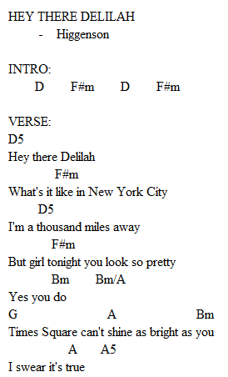
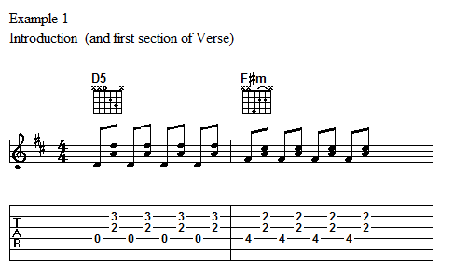
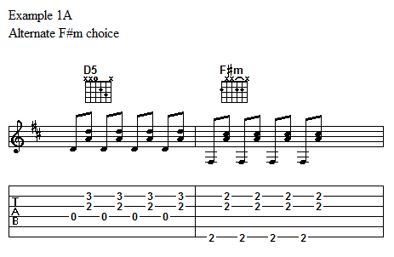
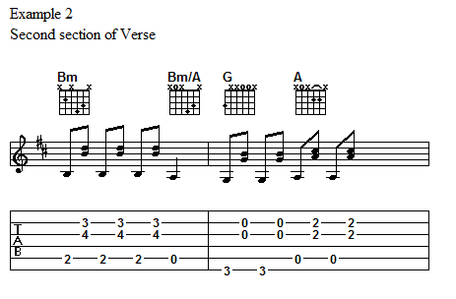
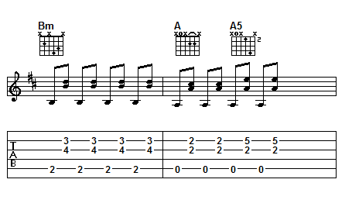
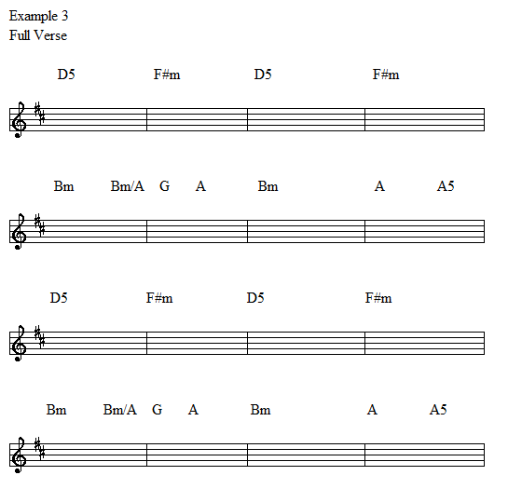
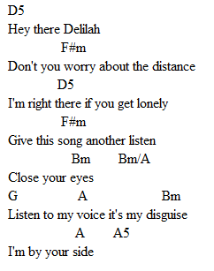
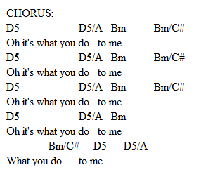

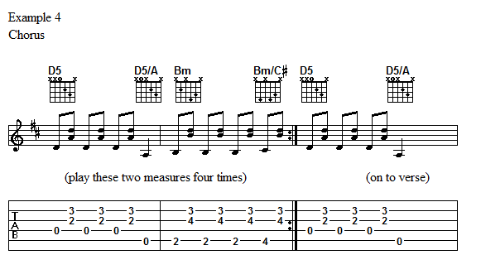
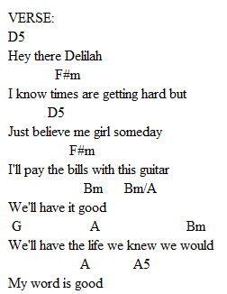

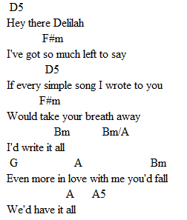
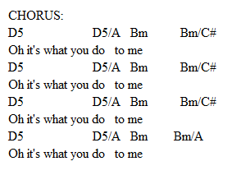

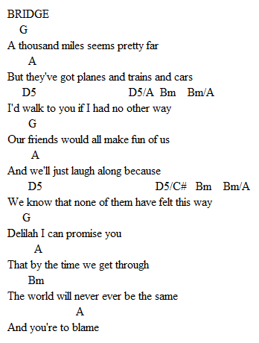

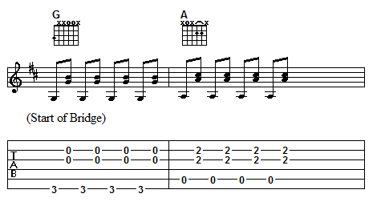
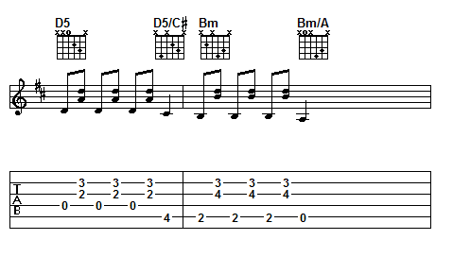
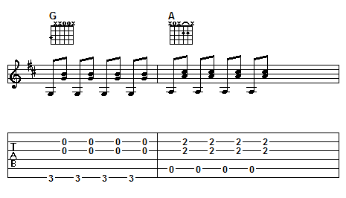

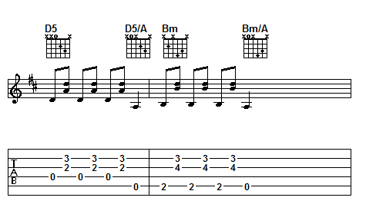
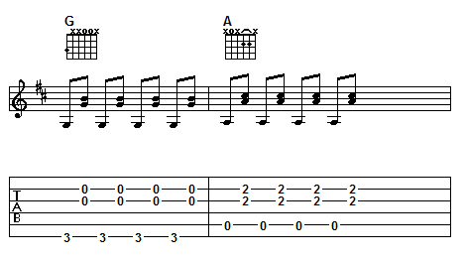
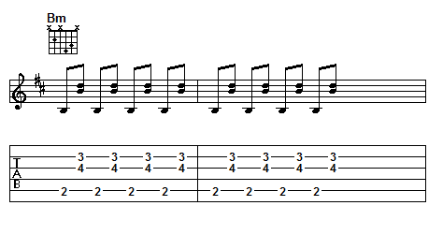

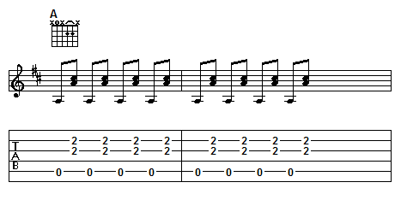

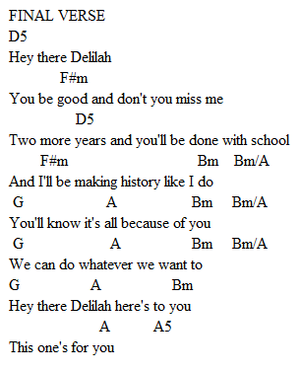

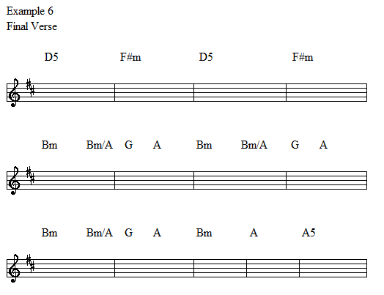
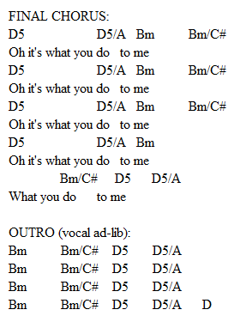

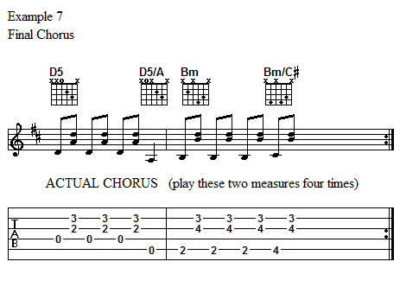
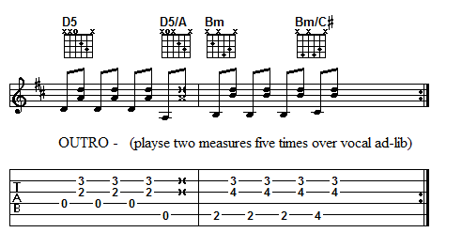
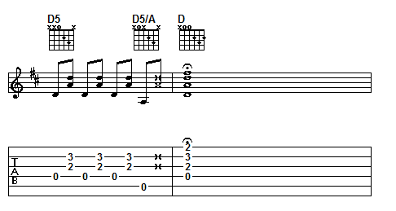
DAY 7

TIME TO PLAY

Grab your guitar and keep playing. Practice the songs you've been working on throughout the week. I'm going to add one final song so that you have a small variety to start mastering.

“SEVEN NATION ARMY”-
THE WHITE STRIPES

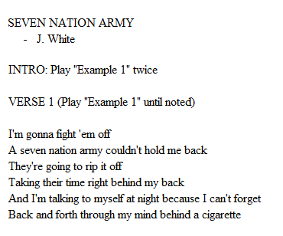

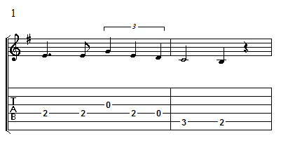
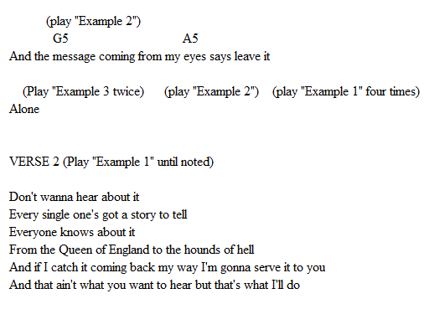
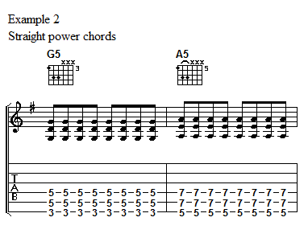
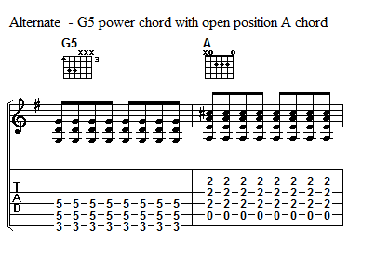
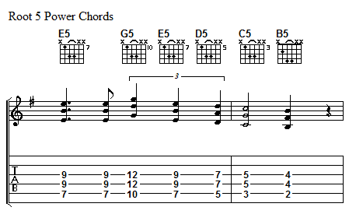
Here's an alternate example of Example 2 as there are more than one guitar parts in the song. You can choose which you prefer.
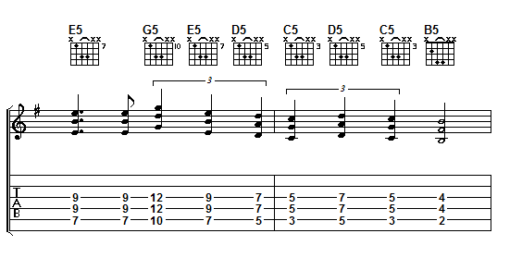
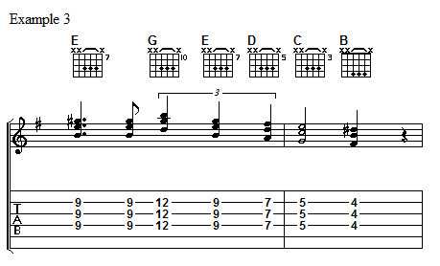
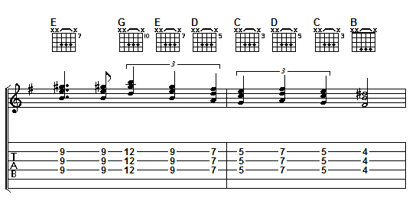
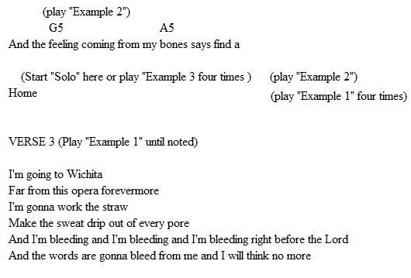
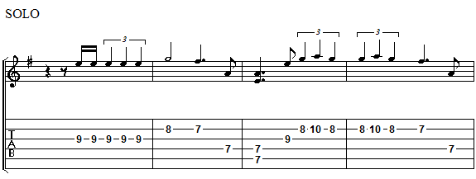
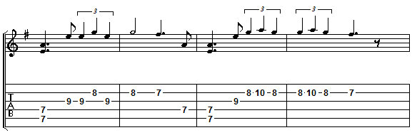
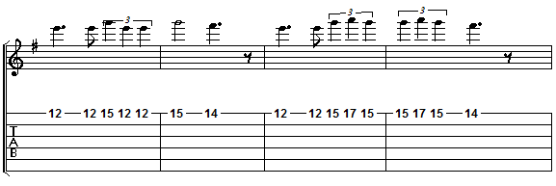
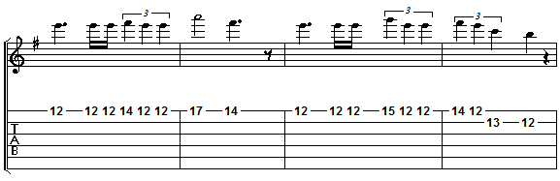

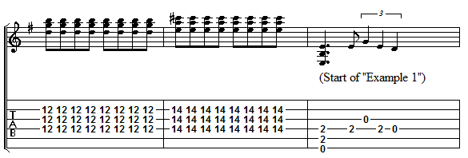
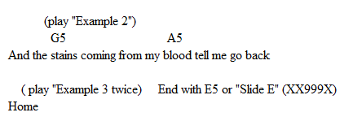

CONCLUSION

As stated in the beginning, playing the guitar can be very rewarding and also very trying. My best advice for you right now is to develop good guitar playing habits. This will save you lots of trouble later on. Take your time and learn your open chords, the corresponding scale, and go slow with chord changes.

Remember, whenever you have to look at your guitar, look down and not over it.

Practice chord changes and progressions till you know them like the back of your hand. Once you have a good feel for your 5 basic chord forms, try the CAGED system. Don't be afraid to sing the chords to yourself while you learn.

Most importantly, relax when you play and have a good time! There's a lot to know and it's not going to happen overnight, but I know if you put your heart into it, you’ll be playing like a pro in no time!

All the best in your Guitar Adventures!

